

***Entity Framework***

**Lab Guides**

|  |  |
| --- | --- |
| Document Code | 25e-BM/HR/HDCV/FSOFT |
| Version | 1.1 |
| Effective Date | 20/11/2012 |

**Hanoi, 07/2019**

RECORD OF CHANGES

|  |  |  |  |  |  |
| --- | --- | --- | --- | --- | --- |
| No | Effective Date | Change Description | Reason | Reviewer | Approver |
|  | 01/Oct/2018 | TuTB create new | Draft |  |  |
|  |  |  |  |  |  |
|  |  |  |  |  |  |
|  |  |  |  |  |  |
|  |  |  |  |  |  |
|  |  |  |  |  |  |
|  |  |  |  |  |  |
|  |  |  |  |  |  |
|  |  |  |  |  |  |
|  |  |  |  |  |  |

Contents

Lab: Get started with ASP.NET Identity 4

Objectives: 4

Prerequisites: 4

Problem Description: 4

Guidelines: 4

Step 1: Create an ASP.NET MVC application with Individual Accounts 4

Step 2: Creating a user. 5

Step 3: Register user 6

Step 4: Sign in. 7

Step 5: Log off. 7

|  |  |
| --- | --- |
|  | **CODE: NWEB.M.L009**  **TYPE: MEDIUM**  **LOC: 300**  **DURATION: 60 MINUTES** |

# Lab: Get started with ASP.NET Identity

Objectives:

* Learn to use ASP.NET identity

Prerequisites:

* N/A.

Problem Description:

ASP.NET Identity is implemented using the following procedure. The purpose of this article is to give you a high level overview of ASP.NET Identity; you can follow it step by step or just read the details. For more detailed instructions on creating apps using ASP.NET Identity, including using the new API to add users, roles and profile information, see the Next Steps section at the end of this article.

Guidelines:

### Step 1: Create an ASP.NET MVC application with Individual Accounts

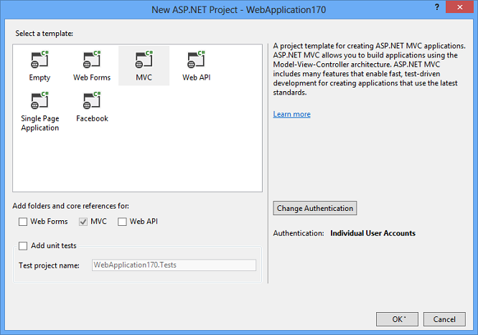

### Step 2: Creating a user.

Launch the application and then click on the Register link to create a user. The following image shows the Register page that collects the user name and password.

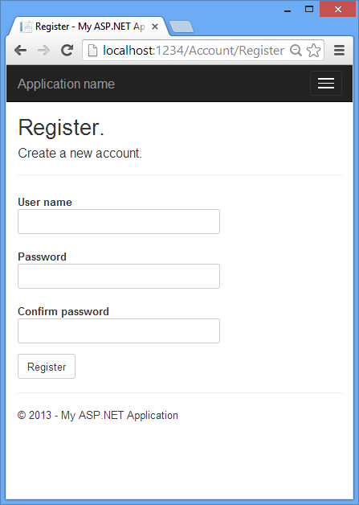

### Step 3: Register user

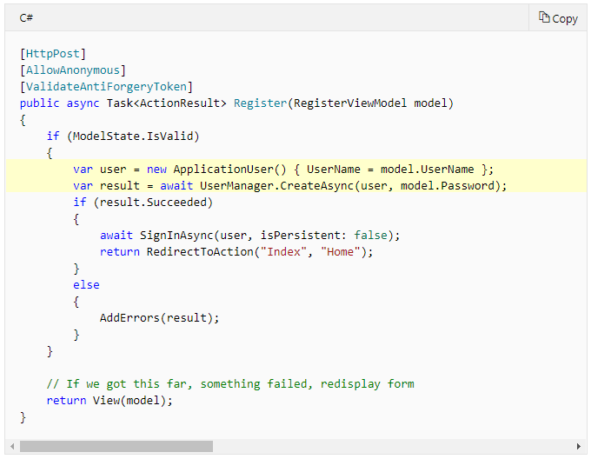

### Step 4: Sign in.

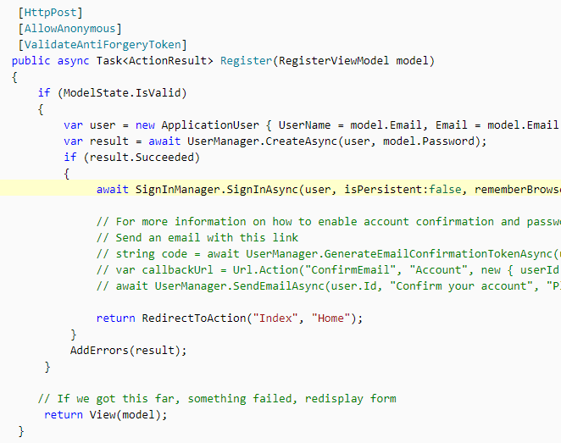

### Step 5: Log off.

